Dandenong & District Netball Association Te Wero Ki Poipiripi
FAST 5 TOURNAMENT
DATE: COMMENCES JUNIORS 13S & 15S 17s
THURSDAY 28TH SEPTEMBER 10:30-3PM
SENIORS MIXED/OPEN FEMALE THURSDAY 28TH SEPTEMBER 6-10PM
Entries Close Monday 24TH SEPTEMBER 2023
HOSTED BY TE WERO SUPPORTED BY D&DNA
Team/Club Association Name
Email
Best Contact Number/s
Name /Organizer
*Please indicate number of teams.
Sections | OPEN | SOCIAL | NUMBER PLAYERS | TOTAL PER PLAYER $20.00 senior  13s &15s 17s $15.00 junior  Registration $20.00
17 MIXED
15s
13s
FEMALE OPEN
SENIOR MIXED NIGHT
*Pending on entries Opens & Social may merge!
Account Name: Te Wero ● BSB: 033-686 ● Acct Number: 679601 ● Ref: Team Name
Dandenong & District Netball Association Inc  .M: 0421101364 Martha | Gloria Pyke Netball and Sports Complex,  Greaves Reserve, Dandenong
E: tewerokipoipiripi@gmail.com | martha@netballdandenong.com.au

Rules
All monies to be settled at reception.
5 Players to take the court GS GA GD GK C
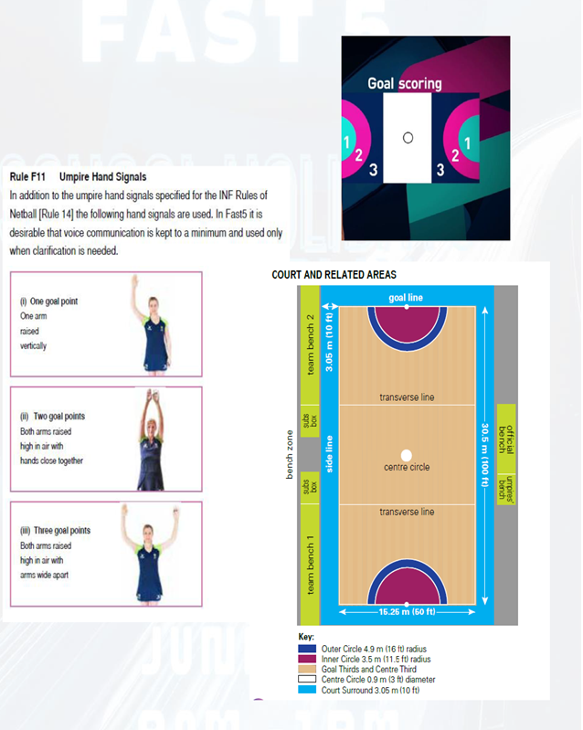
Rolling subs 8 players max 2 males 3 females on court.
Must receive a stamp to take the court.
Toss prior for Powerplay (choose half DOUBLE POINTS) team that does not win has the first C pass.
GS GA must be wholly within the circle to shoot a goal only the C may shoot outside the circle.
Non scoring team will always take the C pass.
3 points Outer Circle
2 Points Inner Circle
1 Point Inside Circle
One scorer from each team (take note of the Umpire hand signals)
Netball Rules apply.
8 mins Halves
No jewelry
Short Nails
No pockets (shorts)
Good idea to bring another set of bibs for rolling subs.
The canteen will be open.

